STD: IV TERM-II (WORKSHEET 3) SUB: SOCIAL
NAME: DATE:
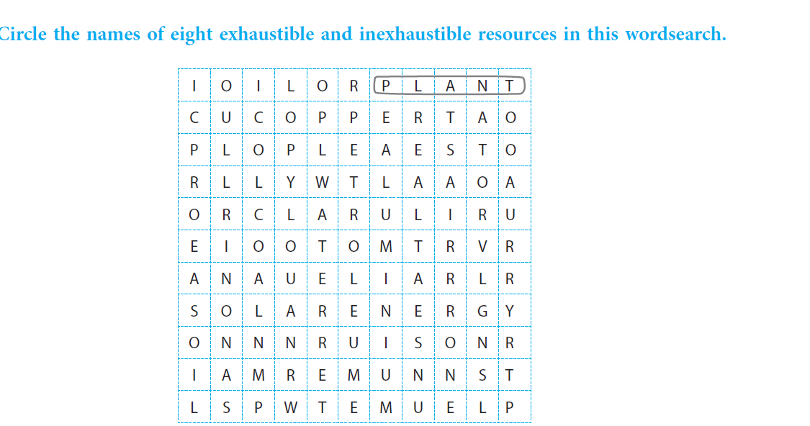
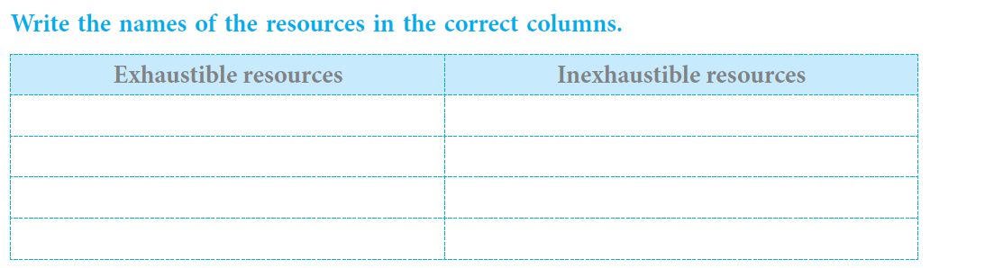
11. OUR NATURAL RESOURCES

